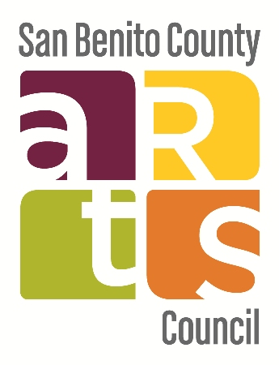 | 

Special Meeting MINUTES
San Benito County Arts Council
City of Hollister Public Art Review Committee

ANYONE WISHING TO ADDRESS THE PUBLIC ART REVIEW COMMITTEE
PLEASE STEP FORWARD AND STATE YOUR
NAME AND ADDRESS TO THE SECRETARY

Persons who wish to speak on matters set for Committee Meeting will be heard when the presiding officer calls for comments from those persons who are in support of/or in opposition hereto. After persons have spoken, the hearing is closed and brought to Committee level for discussion and action. There is no further comment permitted from the audience unless requested by the Chairman.

DATE: Friday, November 20, 2020 TIME: 8:00 a.m.

Join Zoom Meeting

https://us02web.zoom.us/j/89443836647?pwd=ZHM3ak9aeG9McE05U0k5SFh5WFJrUT09

Zoom Meeting ID: 894 4383 6647

Passcode: 163241

Call to Order- AT 8:05 AM

Verification of Agenda Posting- SBCAC posted at 2 pm on 11/17/20; City posted at 4 pm on 11/17/20

Roll Call: Members Present: Daisy Uranda, Chair; Kate Wilbur, Vice Chair; Jennifer Laine, Secretary; Arturo Rosette, Corey Shaffer, Sal Duran
Absent: David Huboi

Oral Communications: Audience comments not related to a General Business item. No action may be taken. Speakers will be limited to 2 minutes.

Approve Minutes from January 30, 2020- Minutes from 1/30/20 were approved msc Shaffer/Wilbur

General Business (30 min)

- Presentation of Downtown upgrades and opportunities for public art by Guest Speaker: Brett Miller, City Manager (Uranda)- PARC welcomed Celina Stotler from SBC Integrated Waste Management who gave a presentation on downtown upgrades, including the parklets, new waste receptables and bike racks. Stotler suggested that there were opportunities to customize the waste receptables with a City logo or public art. Member Laine and Stotler also shared a new public art opportunity for a Bike Rack Mural Project, where 4-6 bike rack murals could be commissioned by the City using COG funding for transportation-related projects. Laine and Stotler cited projects from the City of Atlanta and Redwood City as examples. Stotler also had examples in her presentation about bike rack fabricators, such as Dero. Member Rosette reminded the committee and special guests that PARC is not tasked with doing the actual designing of city logos or other artwork, but can review proposals from RFQs and make recommendations to the city on public art projects. Rosette referenced the Design Logo RFQ that PARC reviewed for the McCarthy Park water tower emblem, as an example. Laine also referenced the Utility Box Mural Project as an example of how the Bike Rack Mural Project could work. Stotler and Laine will continue to work on a proposal, including timeline and costs, to be presented to the City.

- Discuss Committee member terms and next steps (Uranda/Laine)- City Manager Brett Miller joined the meeting to discuss how the City’s committee appointments work, explaining that the vacant PARC seat will be appointed by City Council in January. Member Laine also said that the Arts Council has 2 seats that are at term and will appoint 2 members in January, as well.

- Schedule next Special Meeting for December (Uranda)- Since the regular PARC December meeting would fall on Christmas Day, PARC members agreed to a special meeting on 12/18/20.

Announcements (5 min)- Member Wilbur inquired about the City of Hollister Mural on the Granada Building and asked if anything could be done to refurbish that mural. Member Schaffer said she would confirm who owned that building. Member Rosette said that even if the mural was paid for with public funding (RDA), it still belongs to the building owner since it was installed on a privately owned building. So working with the building owner would be key on any kind of refurbishment project.

Open Forum (time permitting)

Adjournment- Adjourned at 9:14 am msc Rosette/Schaffer

NEXT REGULAR MEETING: TBD

Materials related to an item on this Agenda submitted to the Committee after distribution of the agenda packet are available for public inspection at the San Benito County Arts Council Office, 240 Fifth Street, Hollister. Please contact the Arts Council at 831.636.2787 for office hours and information.

Such documents are also available on the City of Hollister website at www.hollister.ca.gov subject to staff’s ability to post the documents before the meeting.

In compliance with the Americans with Disabilities Act, if you need special assistance to participate in this meeting, please contact the City Clerk's Office at (831) 636-4304. Notification of 48 hours prior to the meeting will enable the City to make reasonable arrangements to ensure accessibility to this meeting. [28 CFR 35.102-35.104 ADA Title II].

Si desea información en español por favor llame al 636-4360 o visítenos al 339 Fifth St. (Calle Cinco) Hollister, CA

